Lab 8 Notes

Exerc. 1

Call the attention that it is Active Directory under Settings for the Synapse workspace. Many students might go straight away to the first Active Directory link they see in the left panel.

It is System Managed Identity, not User.

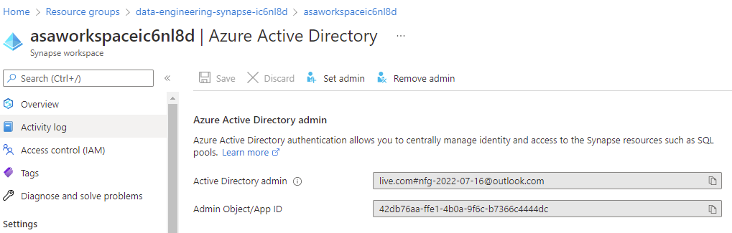

Notice it is a user, but this was not assigned through the UI by clicking Set admin. The initial setup script created and configured the Synapse Workspace. In the UI we have to choose a group.

You can find **asaworkspaceic6nl8d** in AD under Enterprise Applications. There is a Managed Identity with the same name as the application that has been given permissions to the Key Vault.

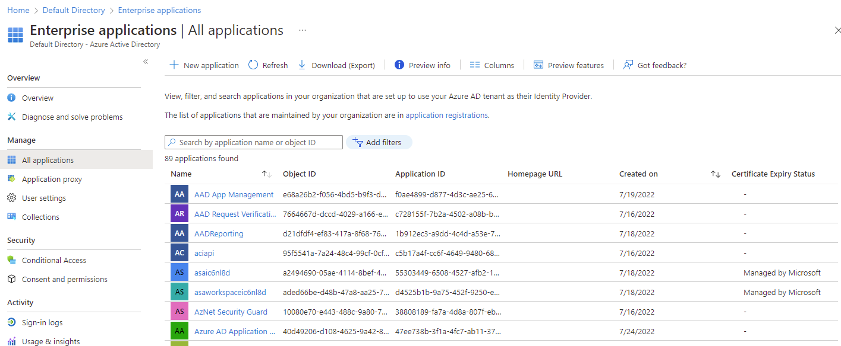

Remove all the filters to see the whole list.